1 March 2022

Dear Director Gerry,

Property tax payers of Lyme need your attention. The Municipal and Property website states that your division oversees the Assessment Review bureau and has the responsibility of monitoring revaluations.

Lyme completed a revaluation for the 2021 property tax year.  The Select Board of Lyme contracted with Todd Haywood, RES, CNHA of Hill Municipal Services, to maintain and update the Town's property valuation, excluding the valuation of utilities in town.

This year's revaluation was not completed in a timely manner. We believe that this delay precluded adequate review before setting the tax rate and issuing property tax bills. We take issue with the results of this revaluation.

We agree with your quote in the DRA press release of November 30, 2021: [NH Department of Revenue Administration Explains Town Tax Rates](https://www.revenue.nh.gov/documents/nhdra-desmystify-tax-rates-release-11302021_FINAL.pdf" \t "_blank)

“In short, just because a homeowners’ assessed value goes up does not mean the amount of property taxes they pay will also go up,” said Gerry. “Assessed value (AV) determines who will be paying the property taxes. While an individual’s AV is important, *the driving force behind how much any property taxpayer will pay is the relationship between their AV and every other property owner’s AV in the city or town in which they reside.” (emphasis added)*

**Problems with sales data**:

During the period stipulated in the assessor's letter to the Select Board (attached), Grafton County Registry of Deeds shows that 172 property transactions occurred, with 115 requiring a transfer tax. The letter to the Select Board states that 61 sales were used for the reassessment analysis, with 54 sales excluded.

We have a number of specific concerns about the revaluation process. We have raised these concerns with the Town of Lyme Select Board and with Mr. Haywood and have not received any substantive answers:

1. The revaluation process excluded 54 properties. We can see that 20 of those were not arms-length sales. That leaves 34 properties without documentation of their disqualification.
2. The 61 properties that were used included 3 that are known not to be “qualified arms-length transactions.”
3. All of the included properties valued at over $1M sold for more than their assessed value.
4. Such a small sample size creates unstable estimates of the various factors that create a measure of “fair market value”, further work must examine how these factors influence the Computer Assisted Mass Appraisal. We have no information about whether this was done.

Of note, 155 River Road was included in the "qualified sales".  This property sale was pre-arranged and not on the open market.  It was certainly should have been considered "unqualified" as an outlier.  While "sales chasing" is not permitted, there appears to be no other explanation for this new appraisal. The appraised land value of its 2.15 acres increased from $327,800 to a whopping $1,621,300. This is completely out of character with the rest of the neighboring river front properties.

**Problems with revaluation results**:

It is reasonable to expect some properties will appreciate more than others. Historically, sales in Lyme had similar ratios of appraisal to market value across all price ranges and locations. The vast differences in tax bill increases for 2021, as a result of this revaluation, do not appear to be a fair and proportionate distribution of the property tax burden.

There are approximately 1000 taxed properties in Lyme, fully 10% had tax increases of more than 20% (Appendix IV). This revaluation appears to have disproportionately increased the appraisals of properties valued below $500,000 in favor of properties valued above $500,000 and even more so, in favor of properties valued in excess of $1,000,000. While very few properties may be appraised over market value, it is the disproportionate increase in the number of undervalued properties that inflates the tax rate and causes excessive tax bill increases and thus an unfair distribution of the tax burden.

Property owners were notified of their new property assessment and given an opportunity to review it if they felt it was in error.  The abatement process is sufficiently intimidating that only a few individuals with high new assessments took advantage of that opportunity. The Town does not provide any data to compare how the new assessment related to the other new assessments.

To improve transparency for himself and his neighbors, a property owner created a Tax Fairness webpage that allows people to compare their tax bill to their neighbors. https://taxfairness.github.io/Taxes2021/

The abatement request form asks the taxpayer to consider and provide evidence that their assessment exceeds "market value". This fails to recognize that properties that are undervalued are just as important in the determination of the fair and equitable distribution of the tax burden as properties that are overvalued.  While abatements may correct a few overvaluations, no one will file for an abatement because their property is undervalued.

We hope that you understand our concerns with the processes and outcomes of the 2021 revaluation of Lyme. Thank you for your consideration.

The undersigned taxpayers of Lyme, NH

WHO WANTS TO SIGN?

cc:

Lindsey M. Stepp, Commissioner

Carollynn J. Lear, Assistant Commissioner

Todd Haywood, Assessor

Select Board, Lyme NH

Appendices: We attach 4 appendices to demonstrate how the revaluation process has produced inappropriate values for properties in Lyme. The first three were created from the Tax Fairness website above. The fourth is a scatter plot created from data we retrieved from the Town website.

Appendix I: Tax Increases - 85 Dartmouth College Highway, a condominium complex:  <https://taxfairness.github.io/Taxes2021/Tax_Increases_85_Dartmouth_College_Highway.pdf>

Appendix II: Tax Increases - Wilmott Way, a quiet road of modest homes: <https://taxfairness.github.io/Taxes2021/Tax_Increases_Wilmott_Way.pdf>

Appendix III: Tax Increases - Breck Hill Road, one of the most scenic roads in town: <https://taxfairness.github.io/Taxes2021/Tax_Increases_Breck_Hill_Road.pdf>

Appendix IV: Scatter plot showing that the lowest value properties had significantly larger tax increases.

Appendix I

21 condominium properties with similar construction and finish, same vintage.

15 decreased taxes

10 of the 12 highest valued properties (over $300K) decreased taxes

5 properties included in “recent sales”, 4 of the 5 sold for more than the new assessed value

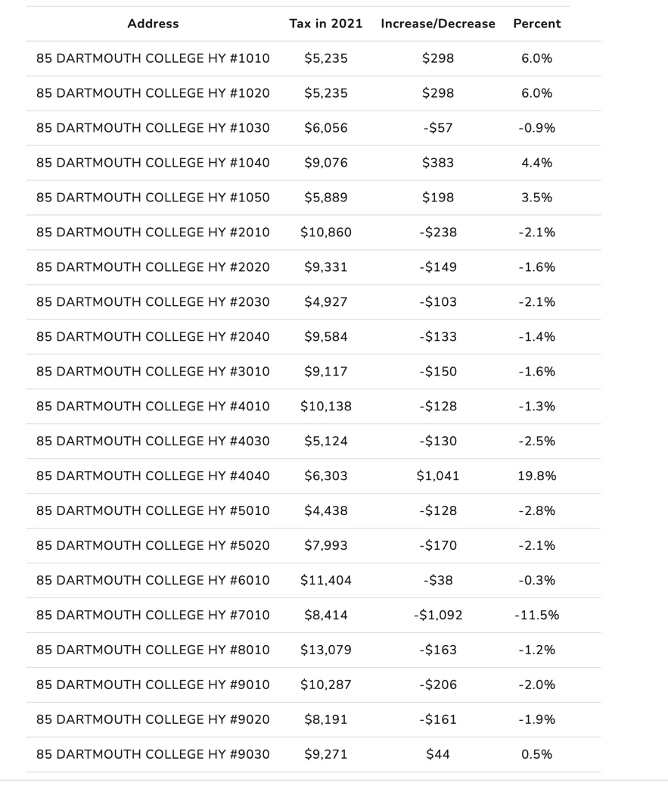

Appendix II

A modest residential dead end dirt road. 8 properties with residences

The 4 lowest valued properties increased taxes the most

#12 and #34 are trailers valued around $100K

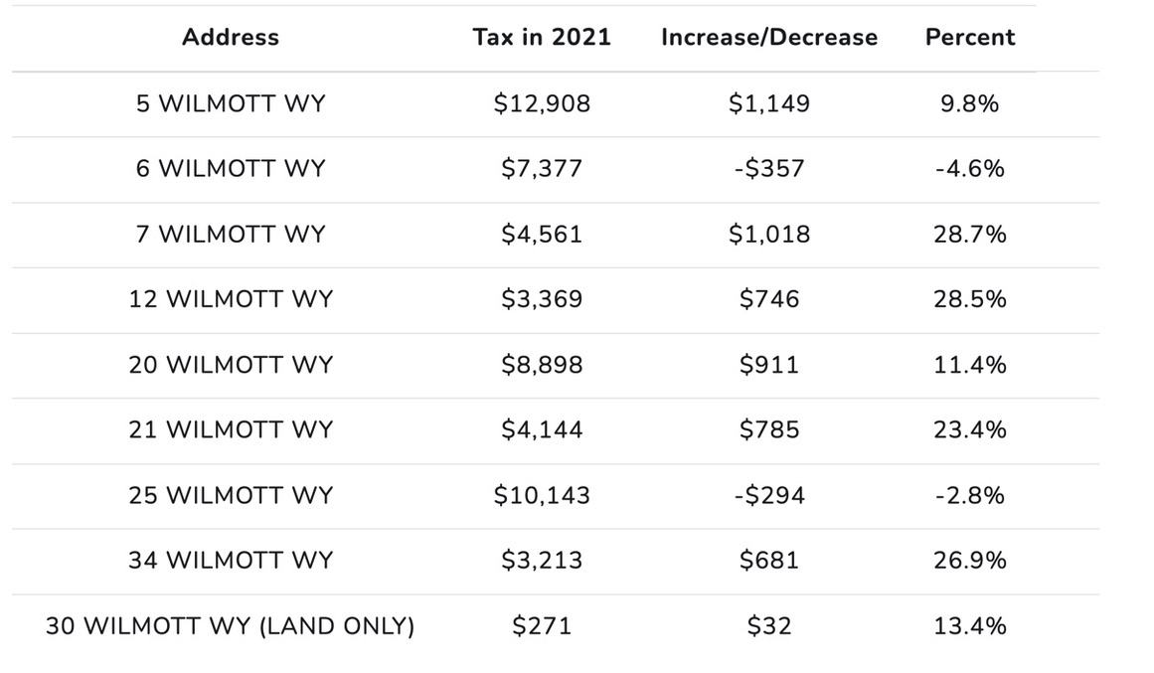

Appendix III

A charming rural dirt road with views and historic homes.

22 properties, 15 homes – 10 homes decreased tax burden

2021 tax bill of $222,369, an overall decrease of $7905.

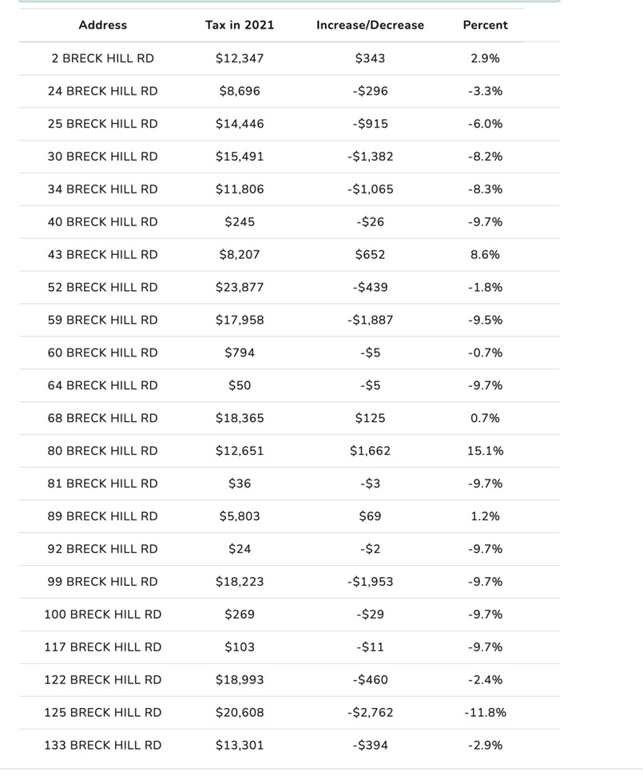

Appendix IV

There are about 500 properties valued between $50k and $500k, 84 of them increased taxes by more than 20%

**Commissioner**

Lindsey M. Stepp

**Assistant Commissioner**

Carollynn J. Lear

**Municipal and Property**

**Director**

**James P. Gerry**

The Municipal and Property Division also oversees the Assessment Review and Equalization bureaus and has the responsibility of:

Monitoring revaluations and revaluation contracts

Todd Haywood, RES, CNHA

Granite Hill Municipal Services

PO Box 1484 Concord NH, 03302

Phone: Office (617) 528-9738, Cell Phone 603-496-7293